**‘R**IALTO **U**NIFIED **S**CHOOL **D**ISTRICT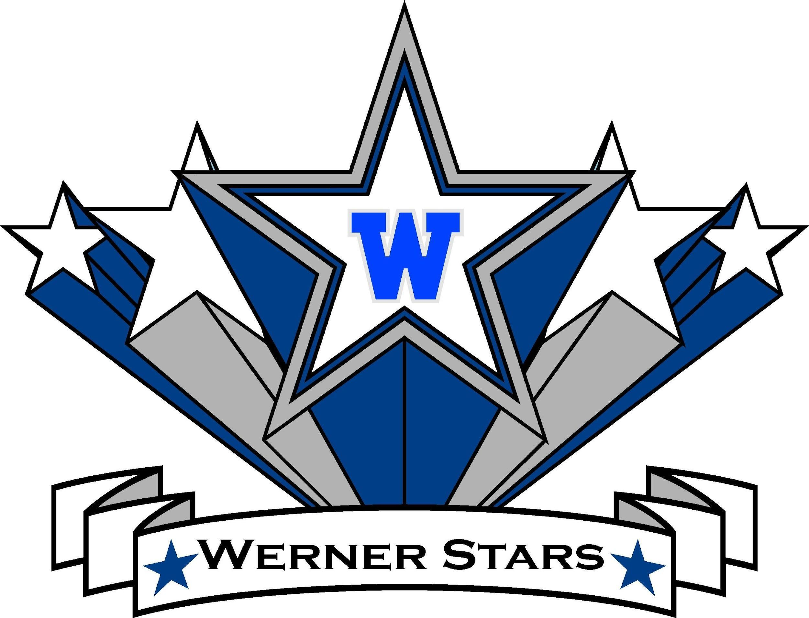

***Charlotte N. Werner Elementary***

1050 W. RIALTO AVENUE, RIALTO, CA 92376

TELEPHONE: 909.820.6830 FAX: 909.562.0078

WEBSITE: http://werner.rialtoschools.org

Dear Werner Family,

I am very excited to have the opportunity to spend another year as the Proud Principal of Werner Elementary. I have been blessed to be a part of the Werner family as a Werner Star for the last two years. I want to continue working in partnership and collaboration with the staff, parents, community, and students to focus on whole-child development while emphasizing academic growth and rigor.

My first priority this year will continue to be to ensure the safety of all students and staff. We will continue to build on Werner’s vision to ensure the academic success and emotional growth of each child in a positive and nurturing environment. We have worked hard over the past two years and are beginning to see a lot of academic gains. I believe that it is critical that we continue to work together as a community to meet both the social-emotional and academic needs of each of our students by focusing on the “whole” child to maximize their abilities, to help them succeed in all of their efforts, and to achieve proficiency in all academic areas.

**The first day of school is on Monday, August 5th.** Transitional Kindergarten begins at 7:45 a.m., and grades Kindergarten through 5th begin at 8:00 a.m. Please join us on July 30th from 8:00 - 12:00 in the Werner lobby to pick up your child’s schedule, our school calendar, and bell schedules. I look forward to meeting all of you in-person at our Back to School Night on Thursday, August 8th at 5:00 PM. I also hope that you will plan on joining one of our parent committees this year and to attend our parent events. My door is always open. Please reach out via email to [tbutler2@rialtousd.org](mailto:tbutler2@rialtousd.org) or by phone at (909) 820-6830 anytime if you have any questions or concerns.

We will continue to update our website with information as it becomes available. We will also continue to use the Parent Square App to keep you updated with information as the new year arrives. Please make sure that you download the app and connect with Werner so that you can communicate with your child’s teacher.

In Partnership,

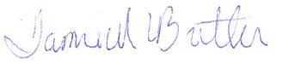

Tami M Butler

Principal, Werner Elementary